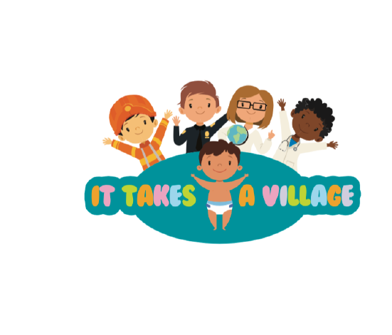

Important Dates and School Closures 2020:
August: 28th (Pajama Day)
September: 7th (Closed for Labor Day)
October: 30th (Fall Harvest Party)
November: 25th (Closing 2:30pm); (Closed 26th and 27th Thanksgiving)
December: 21st Christmas Party, (Winter Break Closed)

